Samantha Paul
Geogebra Lesson: Using the probability calculator to determine normal distribution and binomial probabilities
- At the top of geogebra, click on the “view” button and in the drop down box click on “probability calculator”
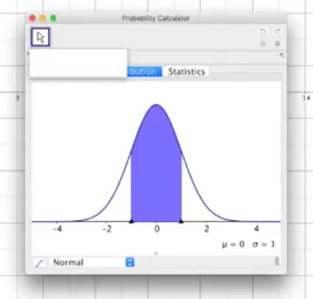
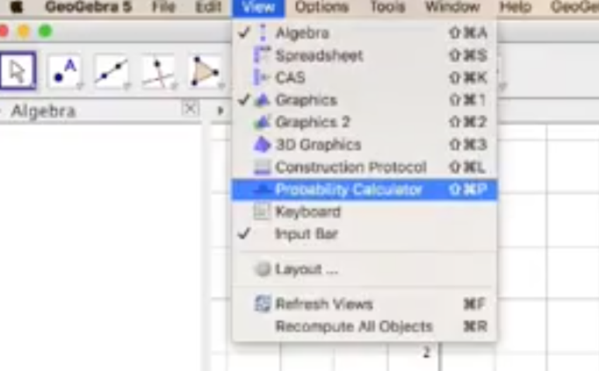
- Standard deviation looks as:
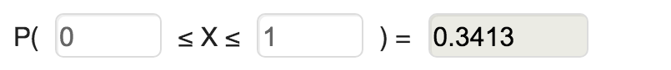
change it to P ( -3 ≤ x ≤ 2)
- Now click on the “ [ “ button
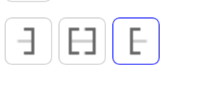
- Change it to P (x ≥ 0.5)
- What is the probability of P (x ≥ 0.5)? ___________
- Now click on the “ ] “ button
- Change it to P (x ≤ 0.2)
- What is the probability of P (x ≤ 0.2)? ______________
- Explain what each of these buttons do:
[ = _______________________________________________________________
[ ] = ______________________________________________________________
] = _______________________________________________________________
- Now insert .9 as the probability to find the x value
What is the x value of the probability of 0.9? ___________________

Using the probability calculator to calculate binomial probabilities
Binomial distribution can be written in the form: X∼ B(n,p)
The random variable X ∼ B(10,2/5). Find:
- P(X=5) b. P(X=8) c. P (X is at least two)
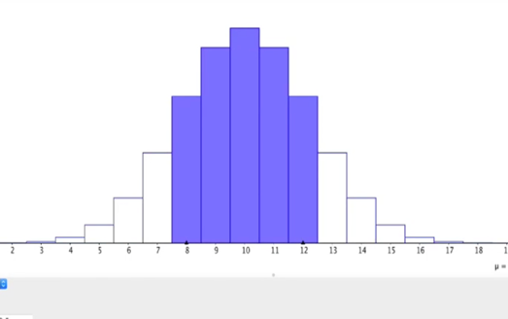
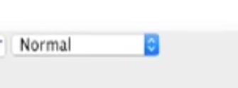
- Go to the button that says normal and clicking the blue button to the right of it. Scroll until you see the “binomial” button

What does that button change? __________________
- In our example our n is ______ and the probability of success (p) is _______
To change this on the graph, change the n to 10 and the p to 2/5 = .4
- To answer part a of the question, make x =5 by clicking the [ ] button and entering 5
P (X=5) = ________________
- Now let’s move on to finding the probability of x=8.
How do we find the probability of x = 8?
________________________________________________________________________ ________________________________________________________________________
P (X=8) =___________________

- We know that if our n is 10, that the deviation goes as high as 10. In order to find out the probability when x is at least two we stay using the button [ ] and insert
P (______ ≤ x ≤ _______)
P (X is at least two) = ______________
- At the top of the page where these buttons lie:
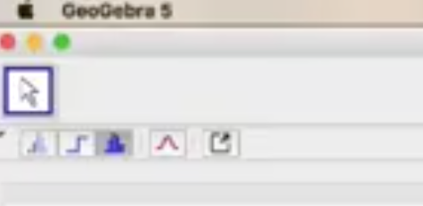
Click on them to see the different ways to view the graph
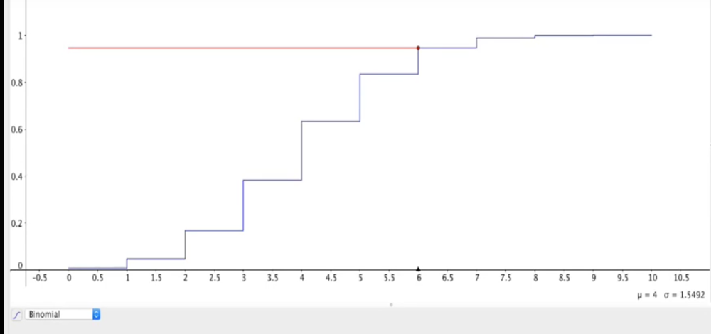

References:
Project Maths Development Team. (2013). Geogebra statistics and probability. Retrieved from
https://www.projectmaths.ie/documents/PDF/GeoGebraForStatisticsAndProbability.pdf
Willis, M. (2017). An introduction to the probability calculator in geogebra. Retrieved from
https://www.youtube.com/watch?v=3fiDmpbw5FY

